**City Day Nursery**

**Summer Newsletter 2016**

**Nursery News**

**We would firstly like to thank all our parents who took the time to write us such fantastic reviews on daynurseries.co.uk, we are all really hoping we have made it into the Top 10 recommended Nursery in Wales category again, as soon as we hear anything, you will be first to know about it!**

**As our nursery continues to develop so does our staff! We would like to Welcome Danielle Corben and Leanne Amour who have joined our City team who will be working alongside the others within the nursery.**

**Congratulations to Natasha Hazel on completing her Level 3 qualification! And is now very excited to start her career as a Nursery Nurse.**

**Facebook**

Did you know we have a Facebook page? If you haven’t already done so, please check out our page and click the like button!

We often update it with pictures of your children getting up to different adventures at City Day Nursery.

**Please Search: Schoolhouse Daycare**



**What’s going on in Swansea?**

* **An Olympic Fun Day in Brynmill Park – 3rs September 2016 – 12pm until 6pm**
* **‘Holiday Memory’ Drop-in Family Workshop at the Dylan Thomas Centre – 29th August 2016 – 1pm until 4pm**
* **Free play Session in Birchgrove – 18th August 2016 – 10.30am until 12.30pm**
* **Stitching Stories Drop-in Family Workshop at the Dylan Thomas Centre - 19th August 2016 – 1pm until 4pm**

**News from the Under 2’s**

**New Toys!**

**What's a babies favorite thing to look at? A toy? No. A geometric shape? Nope. Your baby’s preferred view is a human face!**

**At City we have been kindly given some new mirrored objects for the babies to admire themselves in.**

**While Almanha was looking at her reflection the girls were pointing at parts of her face and naming what they were.**

**Every time they pointed to her nose she started giggling.**

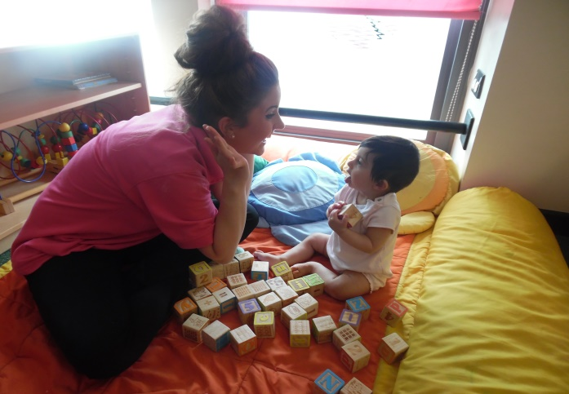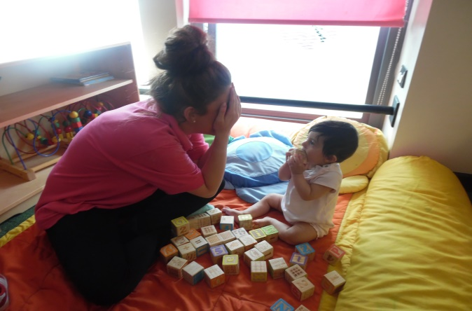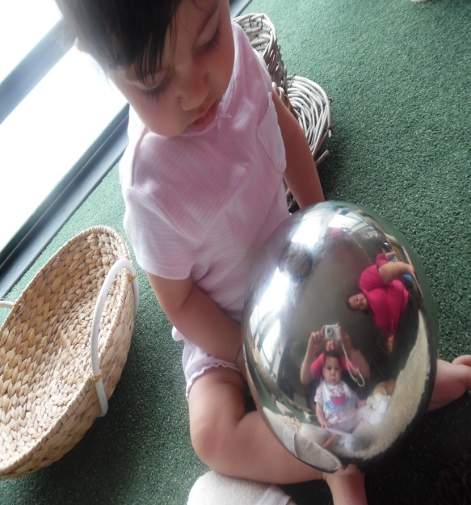

**The Under 2’s Section love playing games! Their favourite is peekaboo!**

**This is such an exciting game for babies as it mimics what they are just coming to understand about the world: that objects and people still exists even when they can’t see them.**

**Understanding this is an important milestone for a baby and it signals they are making leaps in their cognitive development.**

**It looks like Almanha and Hannah are having lots of fun!**

<http://www.thelcswansea.com/>

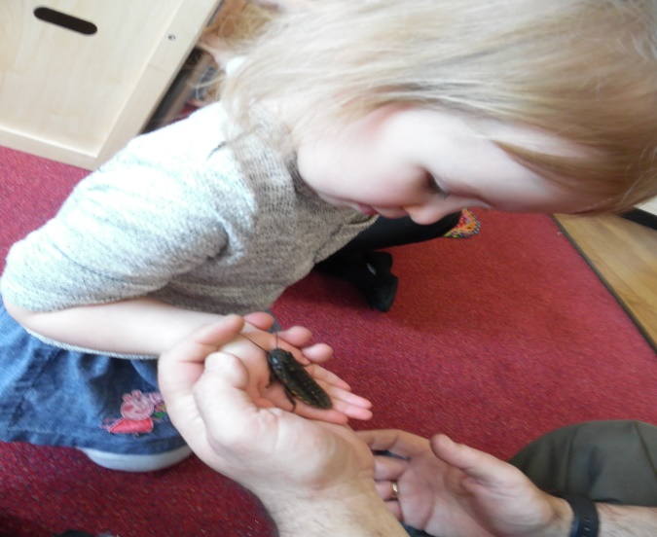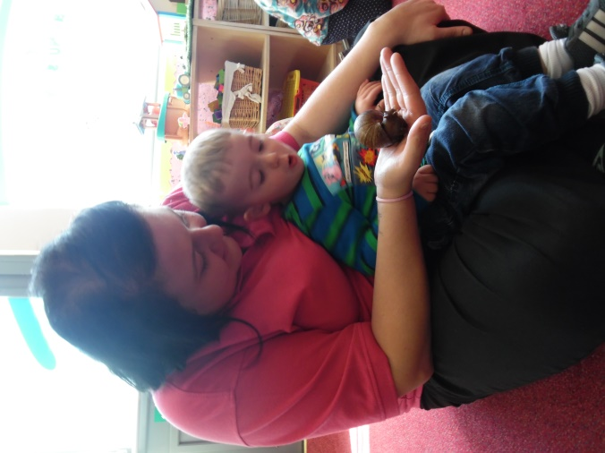

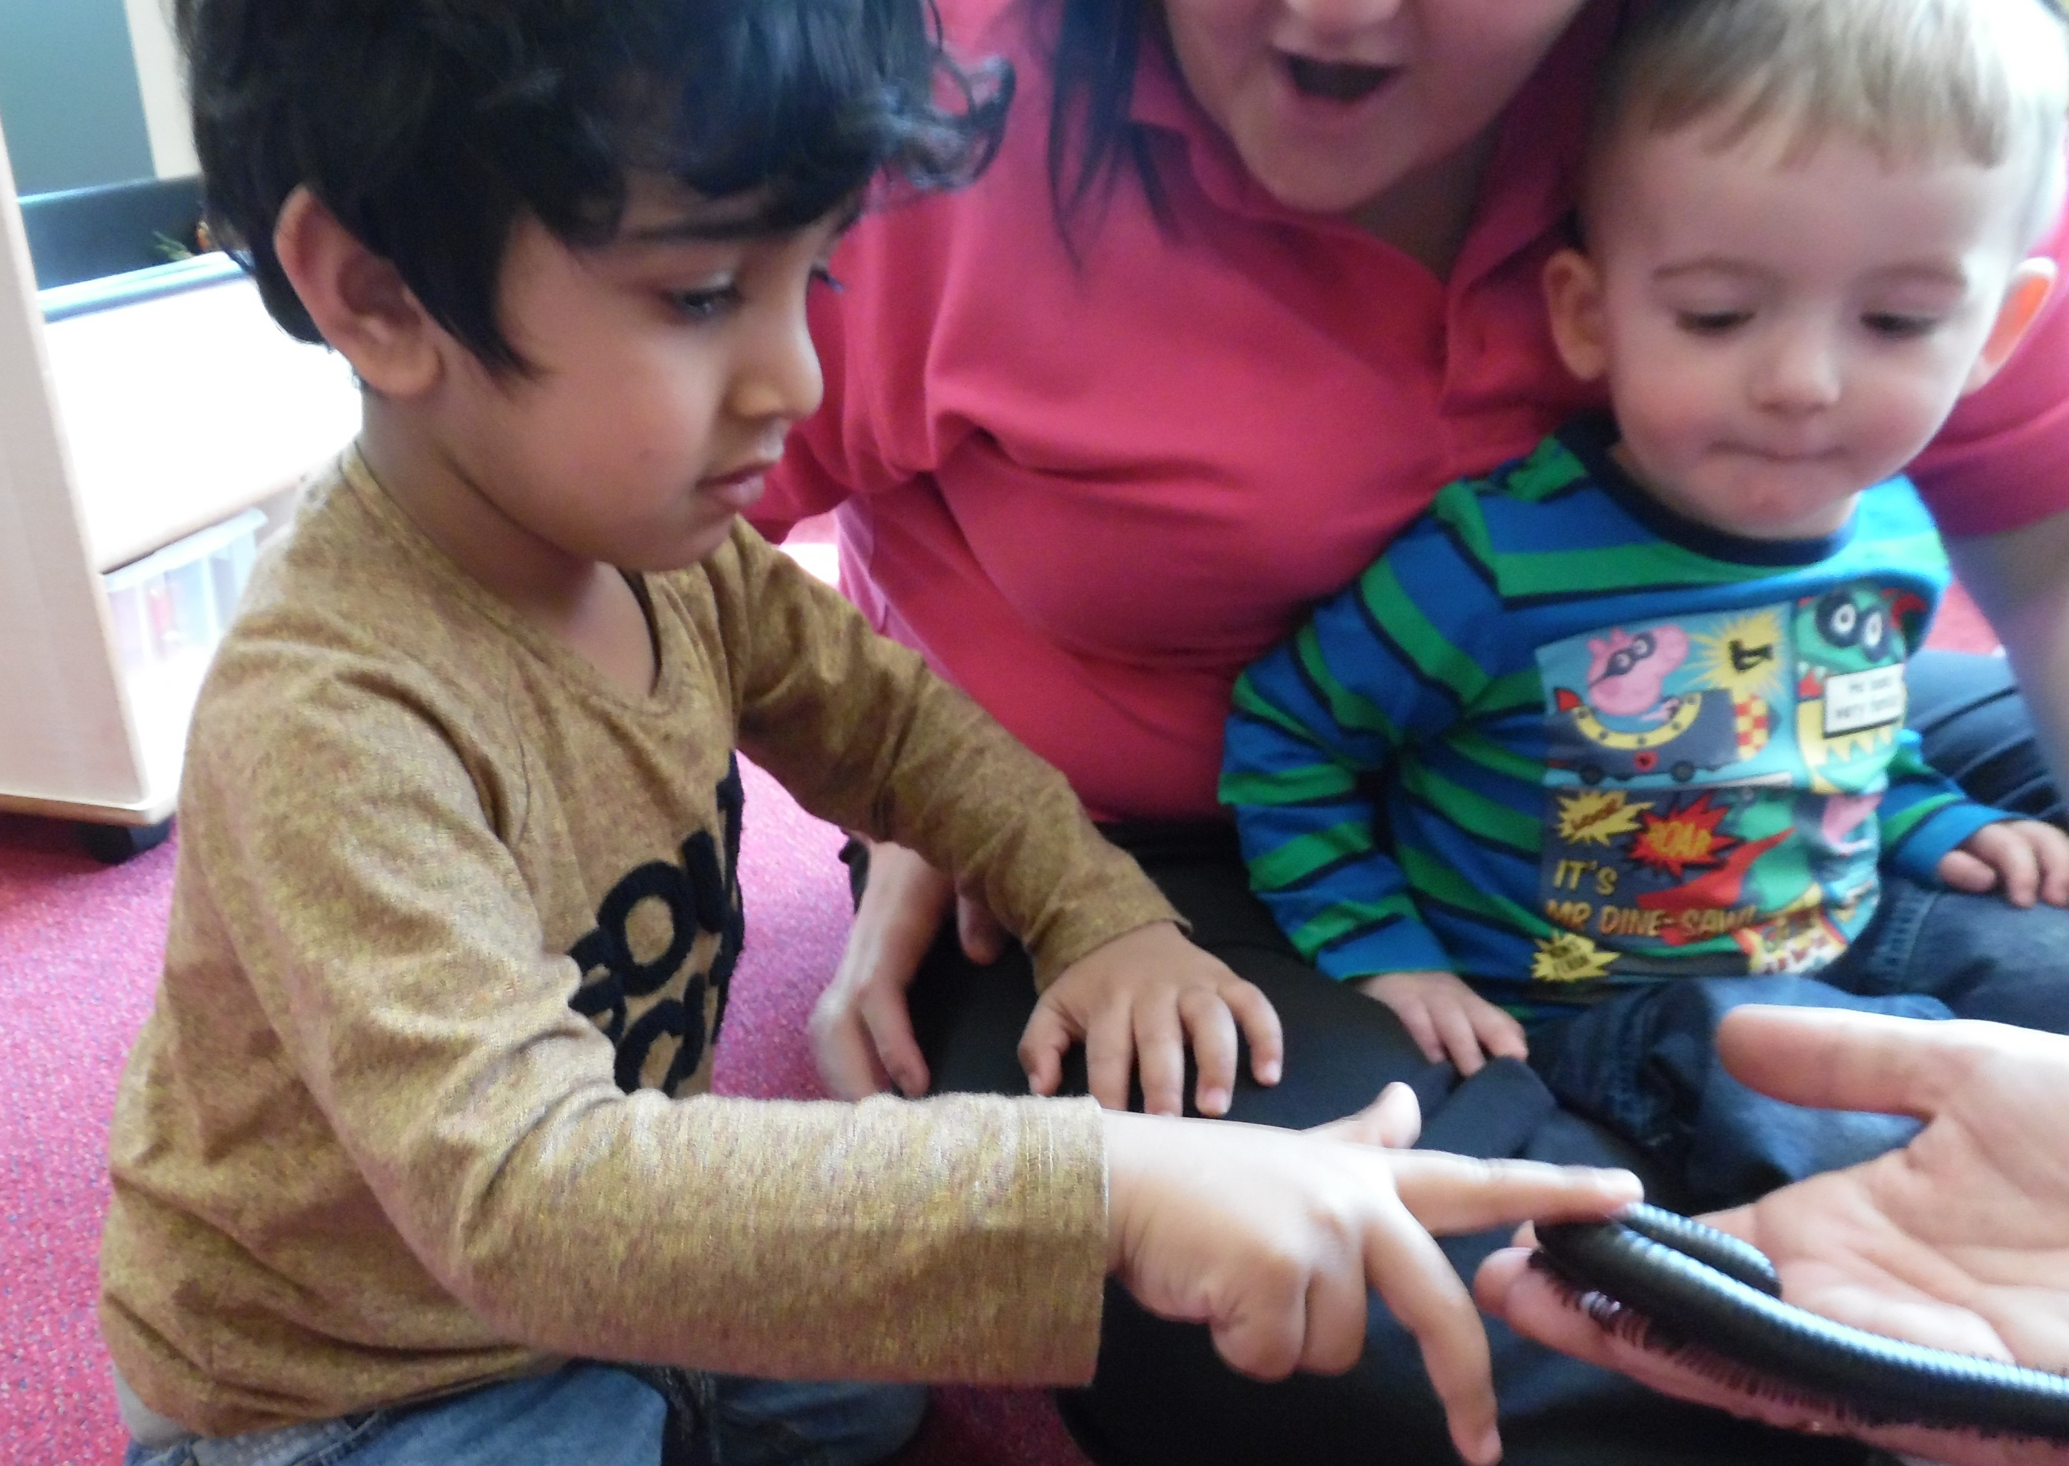

**Zoolab**

The Over 2’s at City Day Nursery enjoyed a visit from Zoolab and all their different animals they brought!

Jade held a very big snail and Lincoln was amazed at his size! He was HUGE!

And Beau was very brave. She held a cockroach and a snake! Well done Beau! I think we have a future zoologist on our hands!

We also had a centipede which had lots and lots of legs! We tried to count them but it had way too many!

**News from the Over 2’s**

