**Spring**

Spring

Newsletter 2024

**Important Dates**

**Welcome**

Welcome to our Spring newsletter from everyone at Princess of Wales Day Nursery.

To begin, we would like to say a big ‘hello’ to all our new children and their families.   
We are looking forward to experiencing plants growing and flowers beginning to bloom in our nursery environment. Be sure to look out for our new & vibrant flowers in the planters out the front.  
Which are your favourites?

**March**

1st – St David’s Day

7th – World Book Day

10th – Mother’s Day

10th – Ramadan Begins

15th – Red Nose Day

17th – St Patricks Day

25th – Easter bonnet competition week

26th – Purple day (epilepsy awareness)

29th – Good Friday (Easter Weekend)

**April**

1st – Easter Monday (nursery closed)

2nd - World Autism Day

3rd – PARENTS EVENING

10th – World Sibling Day

22nd – Earth Day

23rd – St George’s Day

**May**

12th – International Nurses Day

13th – Mental Health Awareness Week

**Spring days**

With our Spring days being so unsettled, some sun, some rain and even some snow & very cold winds, please remember to dress your children in appropriate clothing for the weather. We like to play in the garden everyday, no matter the weather!  
Please can your children come in with labelled wellies and coat and if it is very cold a hat and gloves as well.

We would like to take this opportunity to introduce our new & lovely staff members to our nursery Team

**New Staff Staff19**

**Cara**.  
Cara is also based in our Toddler Room.  
She is very enthusiastic and a keen learner, carrying out studies in her spare time.   
The children love spending time with her and we warmly welcome Cara to our play & learning environment!

**Sasha**  
Sasha is based in our Toddler Room and is Level 3 qualified.   
She has a calm & friendly nature which the children love & enjoy. Welcome to our busy team Sasha!

**Chloe**  
We would also like to take this opportunity to congratulate Chloe on becoming our Toddler Room Supervisor! She has been with the company for over 6years & has lots of experience working with children from birth to 5!  
We look forward to seeing her embed our daily routine whilst inspiring fun play experiences!

**Sue**  
Sue is based in our Baby Room. She is already building strong bonds with all our little babies, whilst gaining the nickname of ‘Nanny Sue’-  
We look forward to Sue sharing her knowledge and caring nature in our Baby Room & Team. Croeso!

**Under 2’s**

We love to be curious & independent.

Our young Babies have been exploring different foods- busy preparing, making, mixing and tasting different flavours & textures.  
We especially loved making our own pizzas on the 9th February for pizza day.

We ate them for our tea, they were very YUMMY!!

**Preschool**

Preschool have enjoyed exploring the great outdoors whilst being closer to nature…

We recently took part in the RSPB’s ‘Big Bird Watch’.   
The children enjoyed looking out for and counting the birds in our nursery garden, going for winter walks, and learning about British Garden Birds.

We even made our own feeders to put out for the birds!

Our Toddler staff & children have recently celebrated children’s Mental Health Week. This year’s theme was ‘My Voice Matters’.

The children took part in some yoga sessions with Cathryn, and she said “not only does it have both physical and mental health benefits, but the children really do also love our yoga time”

Learning to relax and take deep breaths is a big skill we are practising to help with our mindfulness. Yoga & mindfulness forms part of our daily routine.

**Toddlers**

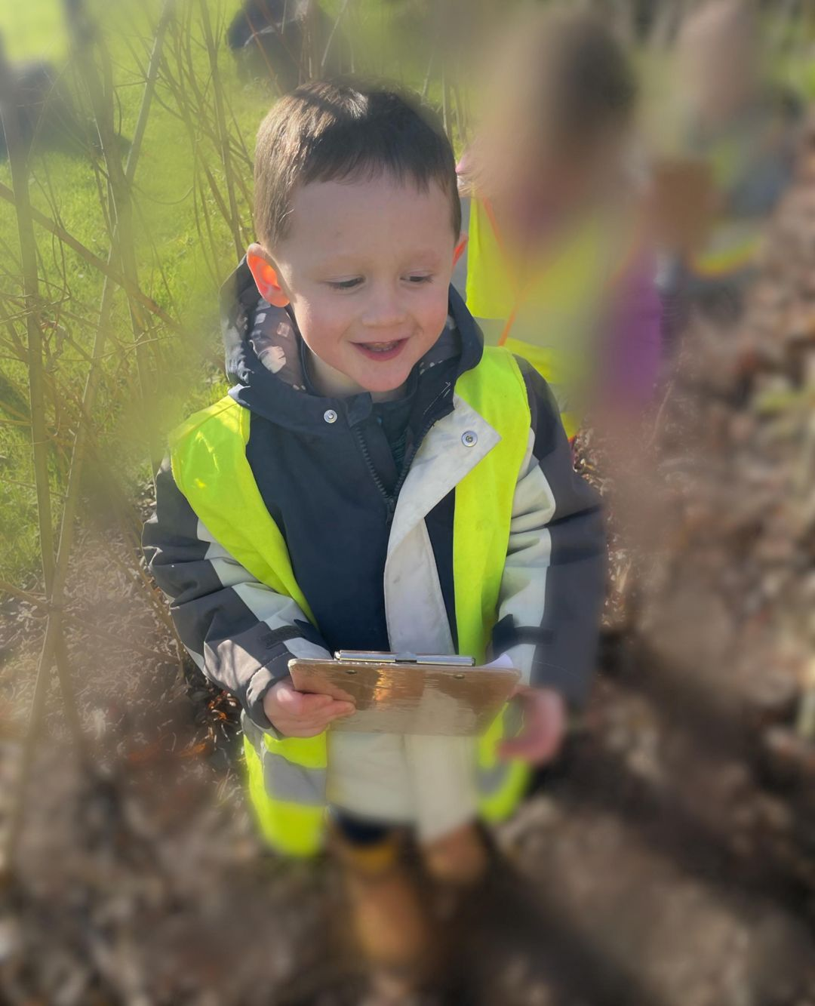

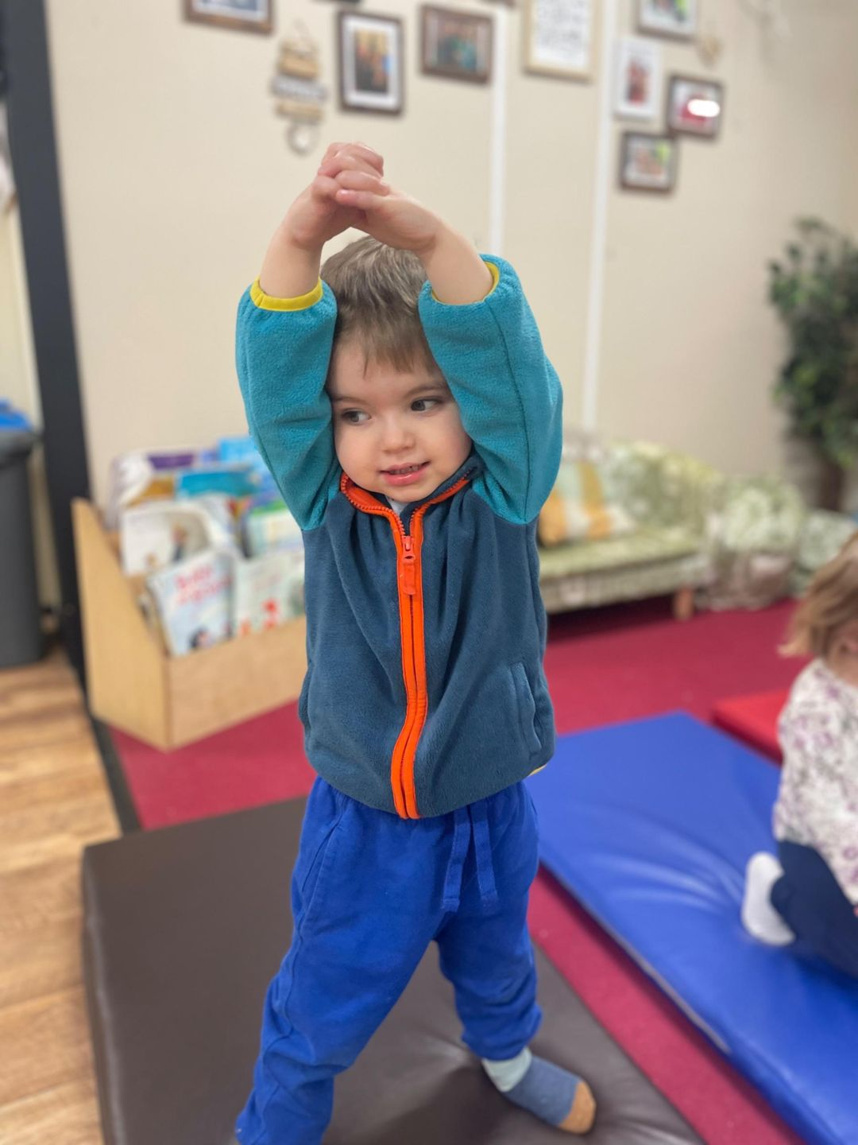

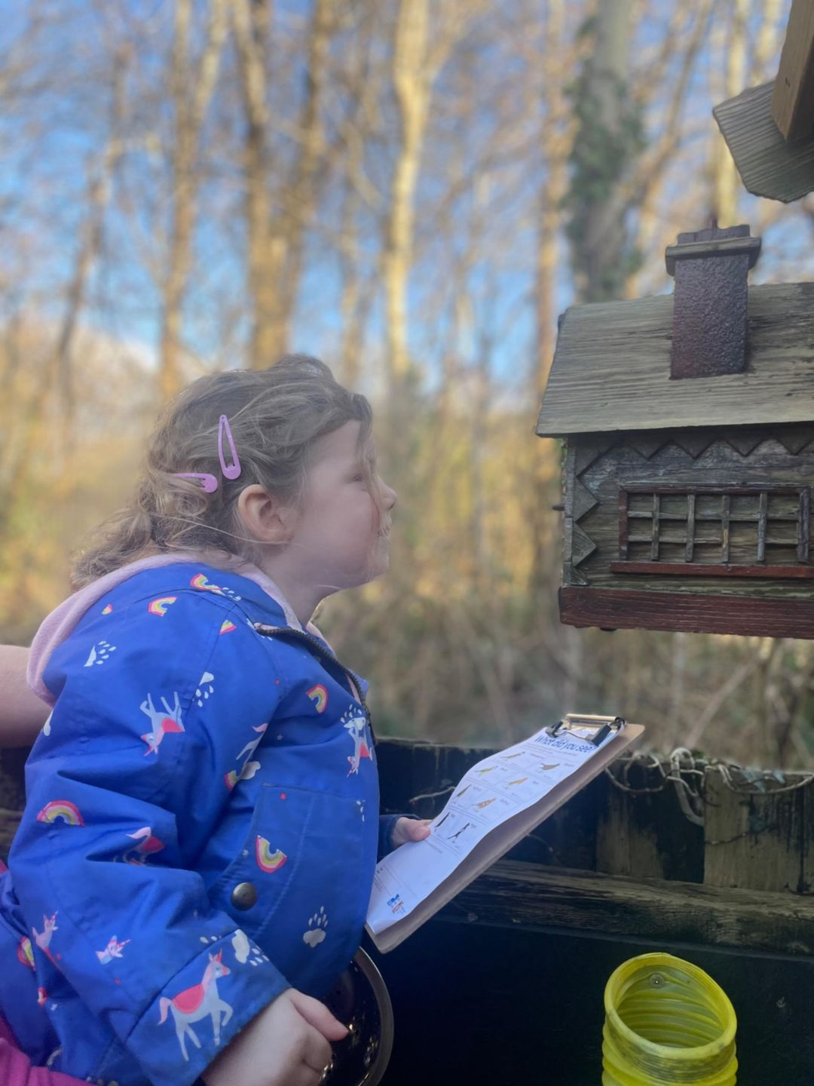

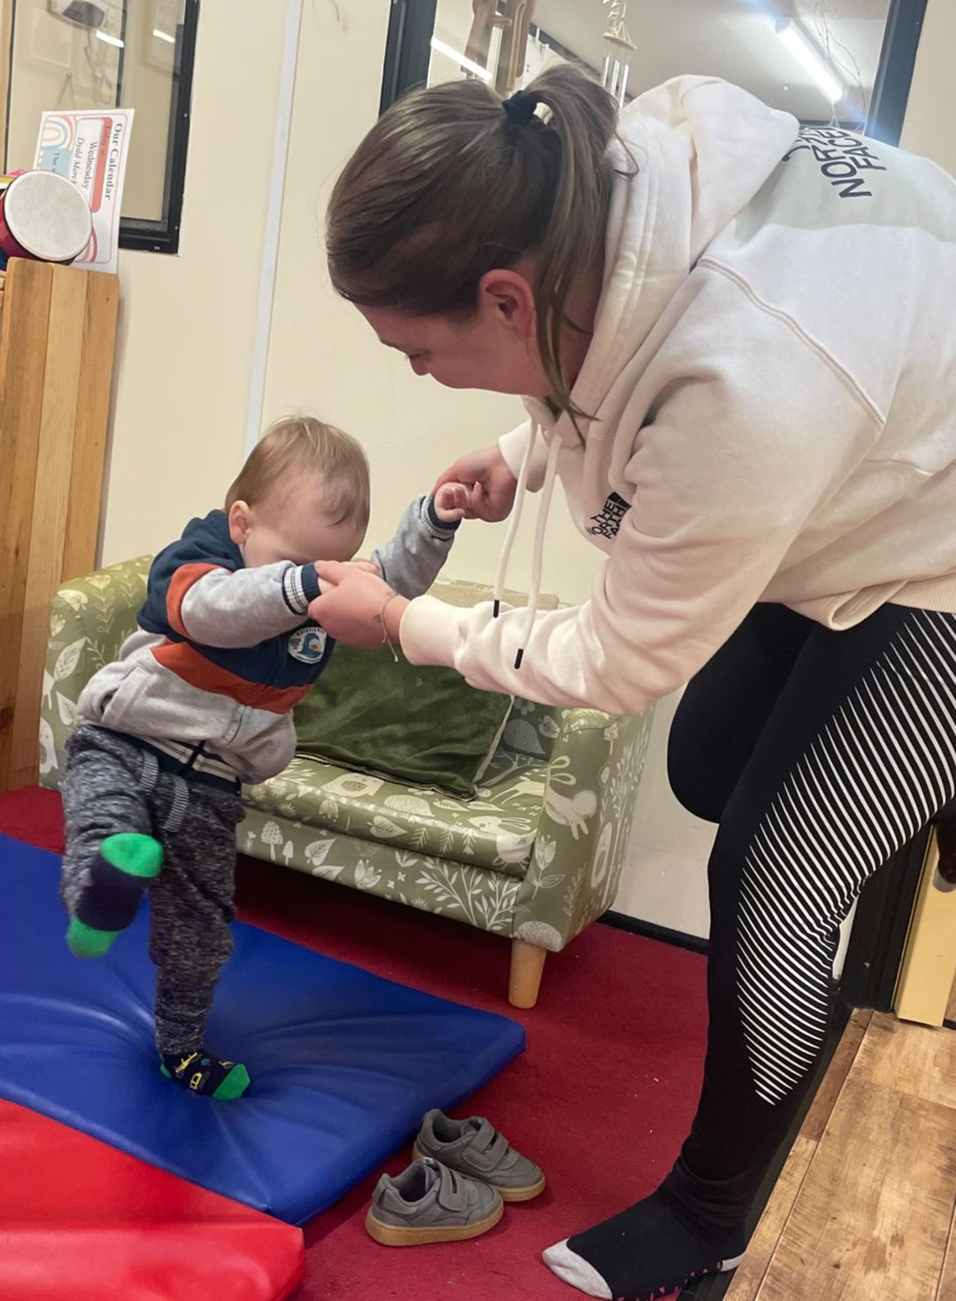

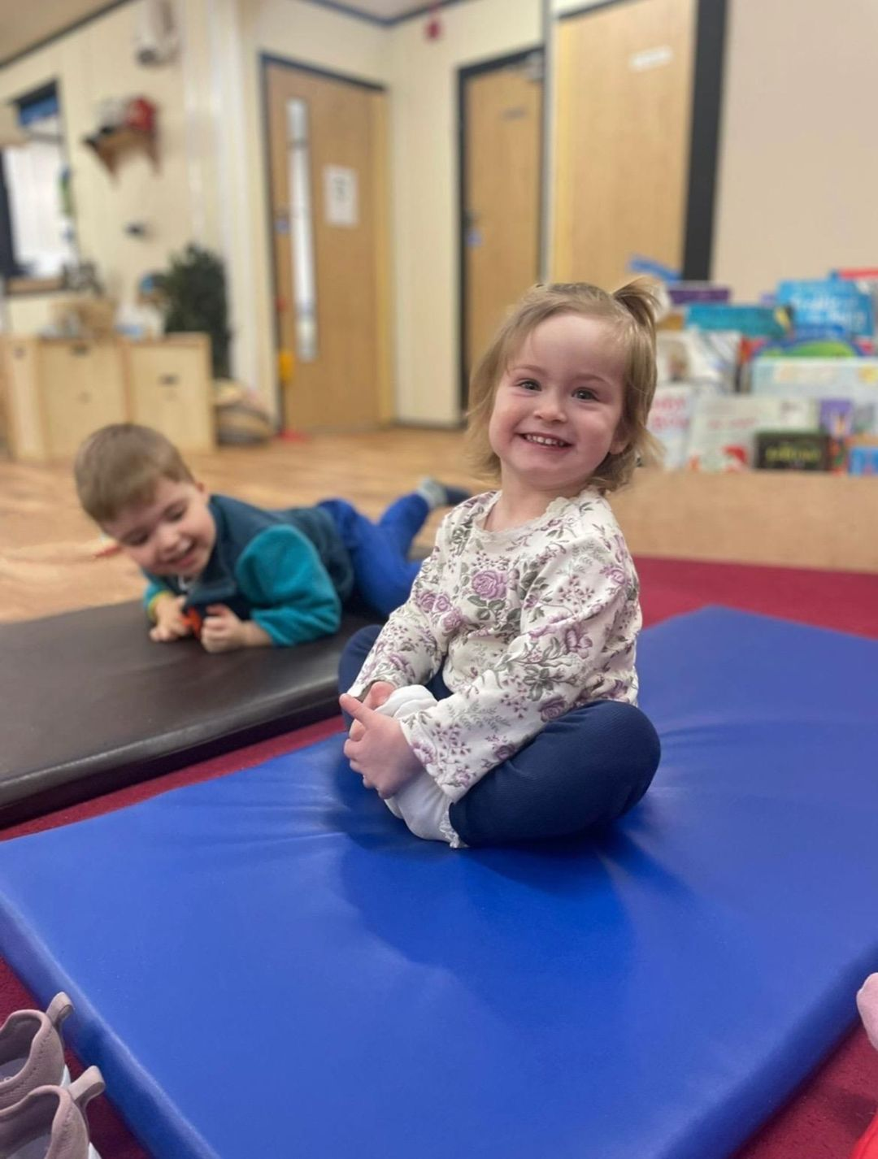

This Spring we will be hosting a variety of nursery events to celebrate Easter with our families, which will include an Easter egg hunt and Easter Bonnet competition. For those parents who are creative or just competitive let’s see what creations we can come up with for our Special Bonnet Event....get crafting!

Easter Home/ Nursery Task

Easter Egg Fruit Pizzas To Try at Home

Things you need:  
- 100g butter (softened)  
- 50g caster sugar  
- 150g self raising flour  
- 8oz cream cheese (softened)  
- Assorted fruits

Directions:  
-Preheat over to gas mark 4.  
- Measure the butter into bowl and beat until softened. Gradually beat in the sugar then the flour. Bring the mixture together until you form a dough.  
-Roll out the dough and using egg cutter cut out the shapes.  
- Bake for 15-20 minutes.  
- Allow biscuits to cool.  
-Spread softened cream cheese over the biscuit  
- Cut up pieces of your favourite fruits and place in your own design.

ENJOY!!!

Follow us on Facebook!

Schoolhouse Daycare Limited

Try something new this summer.

In Rest Bay, Porthcawl ‘Beach Academy’ are running different activities throughout the year.  
Please see below link to see the upcoming activities.

beachacademywales.com/whatson

We have recently received some lovely parent reviews, so a big thank you for taking the time to share your nursery experience. The staff enjoy reading the reviews and seeing your love for our Schoolhouse family as much as we love working here and caring for your children, makes our job worthwhile!

Please see below the link for those who have not written a review yet.

<https://www.daynurseries.co.uk/review-submit/65432129311/rcsid/1012>

Thank you for your continued support.

Look out for free and low-cost events across Bridgend.  
Great ways to keep the family entertained.

<https://awenboxoffice.com/whats-on>

