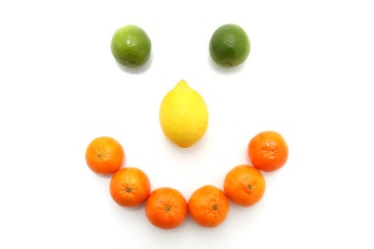

Schoolhouse Daycare Spring/Summer Menu Week 1
 | Monday | Tuesday | Wednesday | Thursday | Friday
Breakfast | Choice of cereal with milk or water | Brioche with Milk or water | Toast with banana and milk or water | Choice of cereal with milk or water | Crumpets with milk or water
Lunch | Beef Lasagne with garlic bread and Vegetables | Veggie Fingers with jewelled rice | Homemade Chicken burgers with potatoes and homemade coleslaw | Sausage, roast potatoes, and peas | Fish fingers with mashed potato and baked beans
Dessert | Ice cream with fruit coulis | Bread and butter pudding | Lemon drizzle sponge cake | Fruit Jelly | Fruit Salad
Babies – Weaning | Broccoli and potato | Carrots and sweet potato | Cauliflower and apple | Parsnip and swede | Mixed vegetables
Tea | Rice cakes with tuna, Greek yogurt, spinach and lemon topping | Pancakes with strawberries and milk or water | Ploughman’s cracker and cheese with sliced tomatoes | Beans on toast | Chicken sandwiches pineapple slices with milk
Babies – Weaning | Banana’s and custard | Apple and pears | Melon smiles | Fromage frais | Banana
Late snack | Sliced Apple | Banana | Sliced Pears | Orange segments | Apple slices

Schoolhouse Daycare Spring/Summer Menu Week 2

 | Monday | Tuesday | Wednesday | Thursday | Friday
Breakfast | Choice of cereal with milk or water | Toasted fruit loaf with milk or water | Choice of cereal with milk or water | Croissant with banana and milk or water | Toast with apples and pears and milk or water
Lunch | Crumbly chicken and mixed veg pie with new potatoes | Homemade corned beef rissole with potato wedges and baked beans | Tuna pasta bake with peas and sweetcorn | Creamy tomato risotto | Homemade chicken goujons with potato wedges and peas
Dessert | Melon | Strawberry mousse | Jelly | Oranges | Chocolate cake
Babies – Weaning | Mixed veg and potato | Swede and carrot | Broccoli and potato | Carrots, peas, and potato | Sweet potato and apple
Tea | Cheese and tomato pizza muffins with apple and milk | Coronation chicken wraps with tomato slices | Crackerbread, Healthy egg salad and cucumber batons | Cheese sandwiches with pepper sticks | Scones and strawberries with milk or water
Babies – Weaning | Fromage frais | Banana | Apple and pears | Banana custard | Mixed fruit
Late snack | Pear slices | Apples slices | Banana | Pear slices | Oranges

