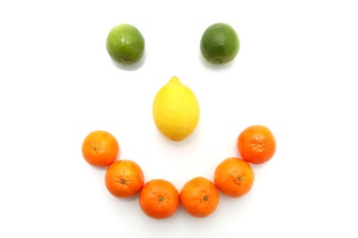

Schoolhouse Daycare Autumn/ Winter Menu Week 1
 | Monday | Tuesday | Wednesday | Thursday | Friday
Breakfast | Choice of cereal | Toasted Bagel with cream cheese | Choice of cereal | Toasted fruit load, milk | Toast with sliced banana and milk
Lunch | Cheese and potato pie with baked beans | Chicken curry with rice and poppadum’s | Soup of the day with crusty bread | Pasta Bolognese | Fish pie and mixed vegetables
Dessert | Bananas and custard | Fruit Jelly | Homemade apple pie custard | Pineapple upside down cake | Melon smiles
Babies – Weaning | Broccoli and potato | Carrots peas and potato | Cauliflower and potato | Parsnip and swede | Sweet potato and peas
Tea | Crispbread with sliced turkey and tomato slices  Milk | Baked beans on toast | Rice cakes with salmon pate and cucumber slices  Milk | Potato skins loaded with cheese and a side of sweetcorn | Cheese sandwiches and tomato slices  Milk
Babies – Weaning | Banana and custard | Mixed berries and apple | Melon | Fromage frais | Stewed apple and custard
Late snack | Apple | Banana | Pears | Oranges | Banana

Schoolhouse Daycare Autumn/ Winter Menu Week 2

 | Monday | Tuesday | Wednesday | Thursday | Friday
Breakfast | Cereal | Crumpets and milk | Toast and milk | Cereal | Brioche and milk
Lunch | Winner Winner sausage dinner | Chili con carne and rice | Chicken and mushroom pasta bake | Cottage pie with broccoli and cauliflower | Fish fingers, creamy mash and baked beans
Dessert | Apple and pear | Home made apple crumble with custard | Jam & coconut sponge | Mixed fruit medley with custard | Fruit Jelly
Babies – Weaning | Mixed vegetables & potato | Swede & carrot | Broccoli and potato | Baby rice and Broccoli | Sweet potato and apple
Tea | Scrambled egg on toast | Chicken stuffing sandwiches and sweetcorn  Milk | Breadsticks with garlic and herb dip and cucumber | Cheesy tuna wraps with tomato slices  Milk | Crispbread with mint yogurt dip and cucumber
Babies – Weaning | Fromage Frais | Banana | Apple & pears | Bananas & custard | Mixed fruit
Late snack | Apples | Pears | Bananas | Apples | Oranges

