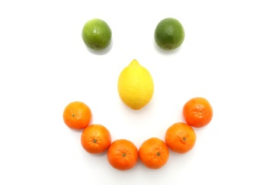Autumn / Winter Menu Week 1
 | Monday | Tuesday | Wednesday | Thursday | Friday
Breakfast | Choice of cereal | Crumpets and banana | Choice of cereal | Toasted fruit loaf, milk | Choice of cereal
Lunch | Chicken and vegetable curry with rice and Naan bread | Cheesy potato pie and baked beans | Chicken and sweetcorn pasta bake with peas | tomato Soup with crusty bread | 100% cod fish fingers, mashed potato with sweetcorn and peas
Dessert | Bananas and custard | Apple & pear slices | Fruit crumble & Ice-cream | Chocolate orange sponge with custard | Bread and butter pudding
Babies - weaning | Baby rice & carrot | Sweet potato & apple | Potato & mixed veg | Parsnip & swede | Potatoes, peas & broccoli
Tea | Toasted tea cakes and pineapple slices | Ham sandwiches with sweetcorn on the side | Yoghurt and paprika dip with bread sticks and cucumber slices | Cheese sandwiches with melon slices | Homemade pizza, apple slices
Babies - weaning | Fromage frais, | Pureed banana | Mixed fruit puree | Peaches | Apple and pear puree
Late snack | Rice cakes | Banana | Cracker bites | Pear | Rice cakes

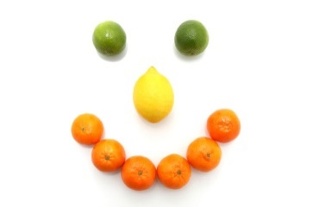

Autumn/Winter Menu Week 2
 | Monday | Tuesday | Wednesday | Thursday | Friday
Breakfast | Choice of cereal | Toast and banana | Choice of cereal | Crumpets and banana | Brioche, milk
Lunch | Cheesy tuna and sweetcorn pasta bake | Vegetarian casserole with rice | Sausage Dinner, new potatoes and veg | Homemade chicken goujons with creamy mash and beans | Pasta bolognaise with garlic bread on the side
Dessert | Melon smiles | Poached pears and custard | Bananas and custard | Pineapple sponge | Apples and pears
Babies - weaning | Sweet potato & parsnip | Potato & broccoli | Baby rice & carrot | Peas & cauliflower | Potato, sweetcorn, and peas
Tea | Baked beans on toast | Cheese on toast with cucumber sticks | Cheesy tuna and mayo wraps with pepper sticks | Crackers, cheese and apples slices | Chicken sandwiches and pineapple slices
Babies - weaning | Pear & peach puree | Pureed apple & custard | Fromage frais | Apple & pear puree | Pureed banana
Late snack | Banana | Cracker bites | Apples | Rice cakes | Banana

