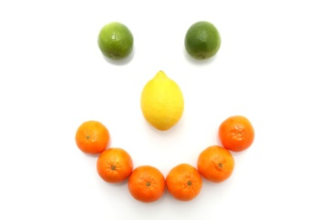Autumn / Winter Menu Week 1
 | Monday | Tuesday | Wednesday | Thursday | Friday
Breakfast | Choice of cereal | Crumpets and banana, milk | Toasted bagel and cream cheese, milk | Toasted fruit loaf, milk | Choice of cereal
Lunch | Chicken curry with rice and poppadum's | Cheesy potato pie and baked beans | Lasagne with mixed vegetables | Leek and Potato Soup with crusty bread | 100% cod fish fingers, mashed potato with sweetcorn and peas
Dessert | Mandarins in juice with vanilla ice-cream | Apple & pear slices | Mixed fruit salad | Chocolate orange sponge with custard | Fruit crumble & Cream
Babies - weaning | Baby rice & carrot | Sweet potato & apple | Potato & mixed veg | Parsnip & swede | Potatoes, peas & broccoli
Tea | Ham, salad pitta pockets | Chicken sandwiches with Carrot Batons | Yoghurt and mint dip with pitta fingers and cucumber slices | Cheese sandwiches with tomato slices | Crackers, apple slices and cheese
Babies - weaning | Fromage frais, | Pureed banana | Mixed fruit puree | Fromage frais | Apple and pear puree
Late Snack | Rice Cakes | oranges | bananas | pears | Buttered Crackers

Autumn / Winter Menu Week 2
 | Monday | Tuesday | Wednesday | Thursday | Friday
Breakfast | Choice of cereal | Mixed fruit and yoghurt | Toast and banana, milk | Brioche and Milk | Choice of cereal
Lunch | Cheesy tuna and sweetcorn pasta | Vegetarian cottage pie with broccoli | Sausage Dinner, roasties and veg | Pasta Bolognaise | Homemade chicken goujons with creamy mash and beans
Dessert | Melon smiles | Banana’s & custard | Fruit jelly | Red Berry Mousse | Pineapple upside down cake and custard
Babies - weaning | Sweet potato & parsnip | Potato & broccoli | Baby rice & carrot | Potato & swede mash | Mixed Vegetables
Tea | Baked beans on toast | Rice cakes, salmon pate and cucumber | Egg and cress rolls with pepper batons | Ham sandwiches and yoghurt | Apple and pear slices, crackers and cheese
Babies - weaning | Pear & peach puree | Pureed apple & custard | Fromage frais | Pureed Banana | Apple & pear puree
Late Tea | Oranges | Pears | Buttered Crackers | Bananas | Rice Cakes

