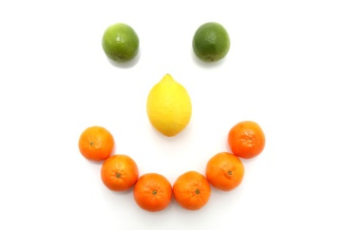Autumn / Winter Menu Week 1
 | Monday | Tuesday | Wednesday | Thursday | Friday
Breakfast | Choice of cereal | Crumpets and banana, milk | Choice of cereal | Toasted bagel and cream cheese, milk | Toasted fruit loaf, milk
Lunch | Chicken curry with rice and poppadum's | Cheesy potato pie and baked beans | Leek and Potato Soup with crusty bread | Lasagne with salad or vegetables | 100% cod fish fingers, mashed potato with sweetcorn and peas
Dessert | Mandarins in juice with vanilla ice-cream | Apple & pear slices | Chocolate orange sponge | Mixed fruit salad | Fruit crumble with custard
Babies - weaning | Baby rice & carrot | Sweet potato & apple | Parsnip & swede | Potato & mixed veg | Potatoes, peas & broccoli
Tea | Ham, salad wraps pockets | Chicken sandwiches with water melon | Cheese sandwiches with tomato slices | Yoghurt and mint dip with pitta fingers and cucumber slices | Crackers, apple slices and cheese
Babies - weaning | Fromage frais, | Pureed banana | Fromage frais | Mixed fruit puree | Apple and pear puree
Late tea | Melon | Yoghurt & fruit | Banana | Bread sticks & tomatoes and Mayo | Brioche

Autumn / Winter Menu Week 2

 | Monday | Tuesday | Wednesday | Thursday | Friday
Breakfast | Choice of cereal | Crumpets and banana, milk | Mixed fruit and yoghurt | Brioche, milk | Choice of cereal
Lunch | Tomato tuna and sweetcorn pasta | Sausage Dinner, roasties and veg | Vegetarian cottage pie with broccoli | Pasta bolognaise | Home made chicken goujons with creamy mash and beans
Dessert | Melon smiles | Fruit jelly | Banana’s & custard | Red berry mousse | Pineapple upside down cake and custard
Babies - weaning | Sweet potato & parsnip | Baby rice & carrot | Potato & broccoli | Potato & wedges | Peas & cauliflower
Tea | Baked beans on toast | Egg and cress rolls with pepper batons | Rice cakes, salmon pate and cucumber | Ham sandwiches with yoghurt and fruit | Apple and pear slices, crackers and cheese
Babies - weaning | Pear & peach puree | Fromage frais | Pureed apple & custard | Pureed banana | Apple & pear puree
Late tea | Rice cakes | Toast | Crackers | Cereal | Fruit loaf

