Singleton - Schoolhouse Daycare Summer 2017
Summer is finally upon us and we are doing lots of exciting things.
From planting pots and getting our garden ready for a fun filled summer.
We are looking forward to spending lots of our day outside and enjoying the improving weather.
Dates for your Diary  - Bank holiday on Monday 28th August We will be open from 8am to 5pm on this day.  - Play scheme is now open Monday to Friday 7am – 7pm up until 1st September.  - Tuesday 1st August the play scheme will be going on a trip to our local beach.  - Thursday 17th August the play scheme children will be going on a walk to Singleton Park to collect and explore natural objects. | Staff Information  We would like to wish Joelene Bellham all the best as she is now gone onto maternity so sending lots of support and love to her and the baby.  We would like to congratulate Gemma Knight on completing her level 5, Well Done.  We also would like to welcome 3 more new starters Rhian Luxton and Vicky Burrington to the over twos team and Saima Mostafa to the under twos team.  We are all looking forward to Jade Osborn returning from her maternity at the end of August.
Health & Safety  Quick note to parents-  Please do not let other parents in to the building for security reasons a member of staff will be with you asap. Also can parents be aware of their speed when driving in and out of the car park,  Thank You | Section Information  Babies  We have been busy welcoming some new starters to the baby section, and celebrated lots of birthdays this month. The babies have been focusing on self-recognition this month using mirrors flashcards and our new black and white display using the children’s photos.  Tweenies  The tweenies have enjoyed learning about mini beasts, we explored the garden using magnifying glasses, the tweenies found ladybirds spiders and butterflies, and we also did bug printing using stamps. We had a lovely time at our teddy bears picnic, we read the story and had sandwiches and fruit in the garden.  Toddlers  The Toddlers are really enjoying their new topic of Colours and numbers, We have been doing lots of exciting creative activities using rainbow colours, Messy play and finding numbers and colours in our nursery and outdoor environment.  We also have many of our toddler’s potty training at the moment, this is a very big milestone for the children and we are all very proud of their progress so far.  Pre-school  In pre-school our topic is all creatures great and small. We have been currently learning about Under the sea animals, We have done observational paintings on the animals and been learning the different names of the animals, We also had a water area in the classroom so we could look at toy bugs in the water and discuss facts about each animal. To finish off this part of the topic we took a trip to singleton park to visit the pond and observe the fish, on our way back we collected natural objects as we are now moving onto looking at Bugs. The children really enjoyed visiting the pond so we have planned to go back at the end of the bug topic. We will now learn about bugs in our environment and do lots of fun and exciting activities that the children will enjoy.  (All activities we have been doing cover the seven areas of development).

FAQ’s
If you are giving dates for upcoming months please can you make sure that the dates are in before the 20th of the month as now the invoices are being produced on that date?
Many thanks.
Things to do at home

Creating pictures in a fun and exciting way
This is a fun and exciting activity for the children to enjoy in the garden on a nice Sunny day. It is easy to make and organise all you need is paint, water balloons and White card/paper. Make sure you wear old clothes or wear an apron as this can get Messy. Hope you enjoy.

Recipe
Meatballs in tomato sauce
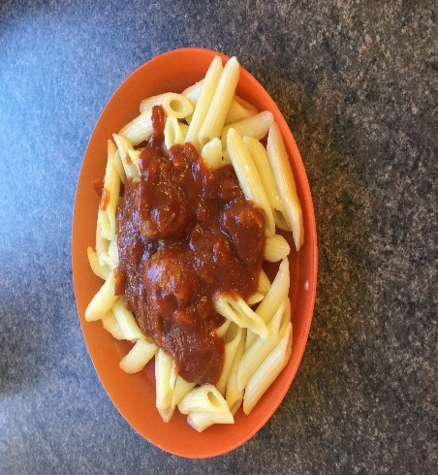
Ingredients
Meatballs Tomato sauce
Vegetable oil Onion
Minced pork Tinned Chopped Tomatoes
Egg Tomato puree
Breadcrumbs Dried mixed herbs
Method
Meatballs
Place mince in a large bowl, add egg and breadcrumbs.
Mix well to combine ingredients. Shape the mix into small balls.
Place meatballs in an oven proof dish with a little oil,
Cook all meatballs until brown in a pre-heated oven.
Tomato sauce
Cook onions in oil
Add chopped tomatoes, tomato puree and herbs to onions,
Bring to the boil and simmer.
Pour sauce over meatballs and place bake in oven for
Approximately 20-30 minutes.
Serve with Pasta
Wish Lists  Home corner items - empty; cereal boxes / shampoo bottles / water bottles (NO meat, fish, nut or egg products)  Old hats | Local Events  Family Craft  28/07/2017 - 11:00 am - 1:00 pm :  Glynn Vivian Art Gallery, Swansea  Come and meet our artists and take part in a series of hands-on, creative art and craft activities for all the family  ‘Holiday Memory’ Journals, Drop-in Family Workshop  04/08/2017 - 1:00 pm - 4:00 pm :  Dylan Thomas Centre, Swansea  Make a journal with secret pockets, fold out pages and hidden envelopes to store all your holiday memories

